**Guangxi Association website plan**

Author: liangjianquan

Date: 2022-11-09

Version 1.0

Overview 3

Design contains 3

Web page hierarchy diagram 3

show content 4

Navigation 5

Home 5

Association Blog 8

News and Events 8

Association members 9

Related Companies 10

Contact Us 10

Backstage Management 11

Technology 11

# Overview

The website mainly introduces the Guangxi Association and shows recent developments and news releases.

# Design contains

The content of the website includes the homepage, recent developments and news, a display of past activities of the Association, members of the Association, contact information, and Backstage Management.

# Web page hierarchy diagram

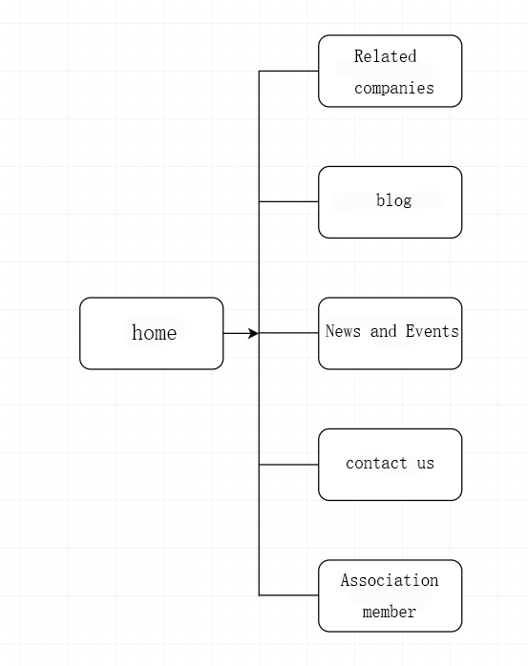

**show content**

The name of domain name applied by the association needs to be provided by the association.

The following is the reference website content.

## Navigation

Home--Blog--News and Events--Association Members--Related Companies--Contact Us

## Home

Introduce association information



Showcase (news, videos, events)

News--upcoming events, important notices, etc.



Video--Showing a video of the event。

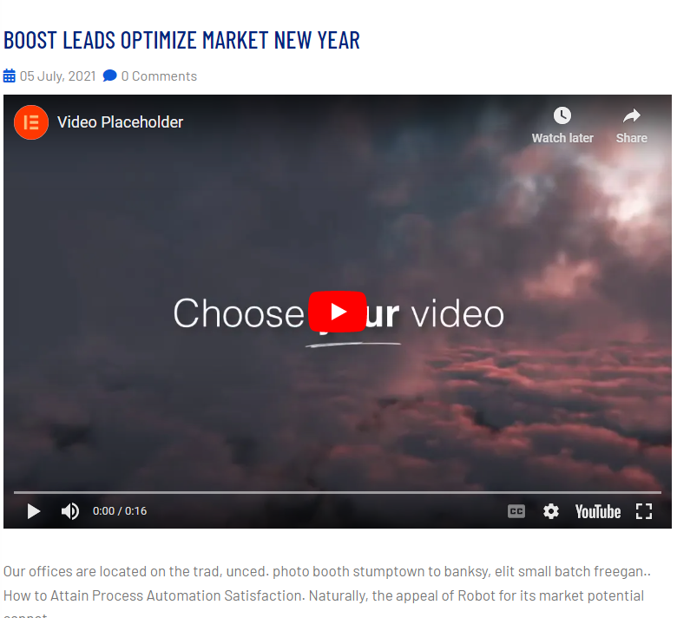

Events - a blog of the latest events.

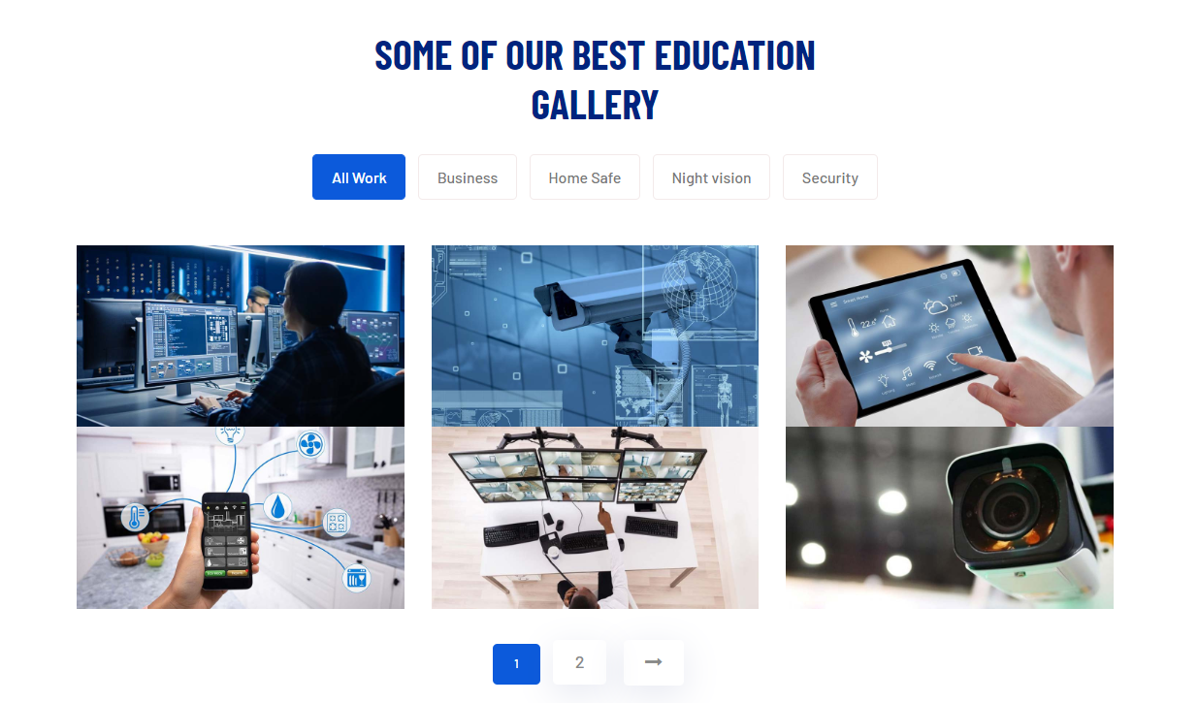

## Association Blog

Display of past activities of the association.

(can be added in the backstage)

(requires the association to provide previous activity documents and pictures).

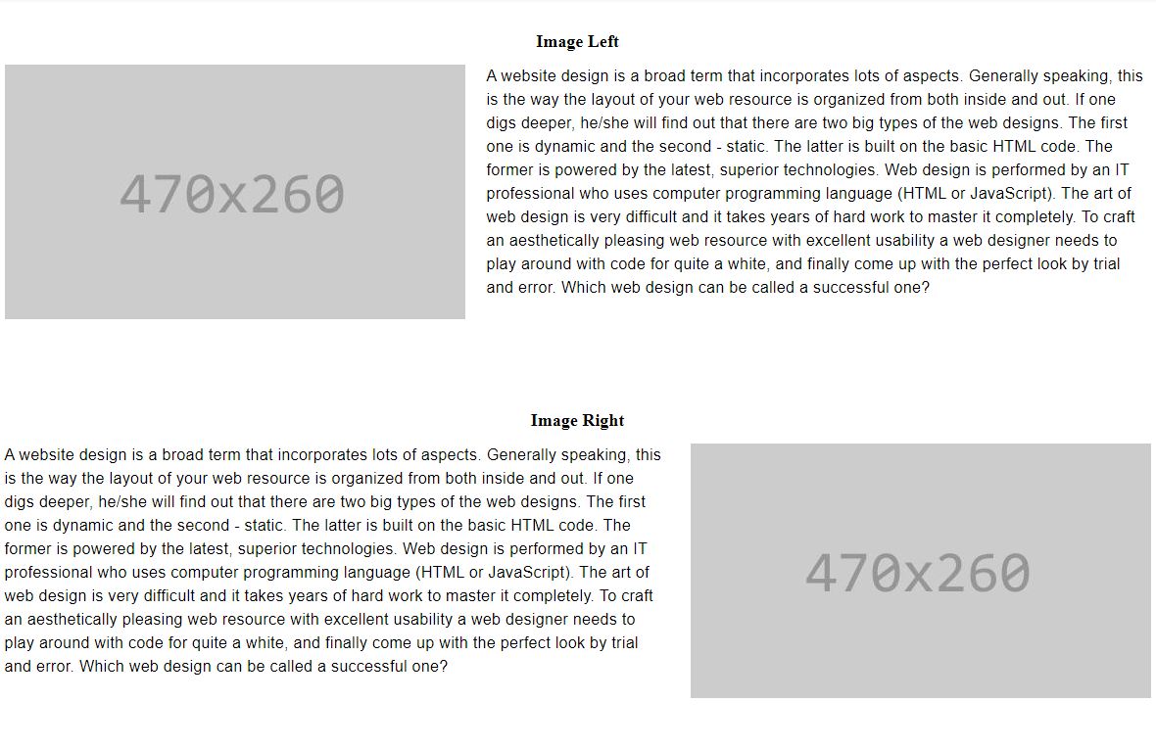

Past videos of the association. (can be added in the backstage) (the association needs to provide relevant video links)

## News and Events

Post upcoming events.

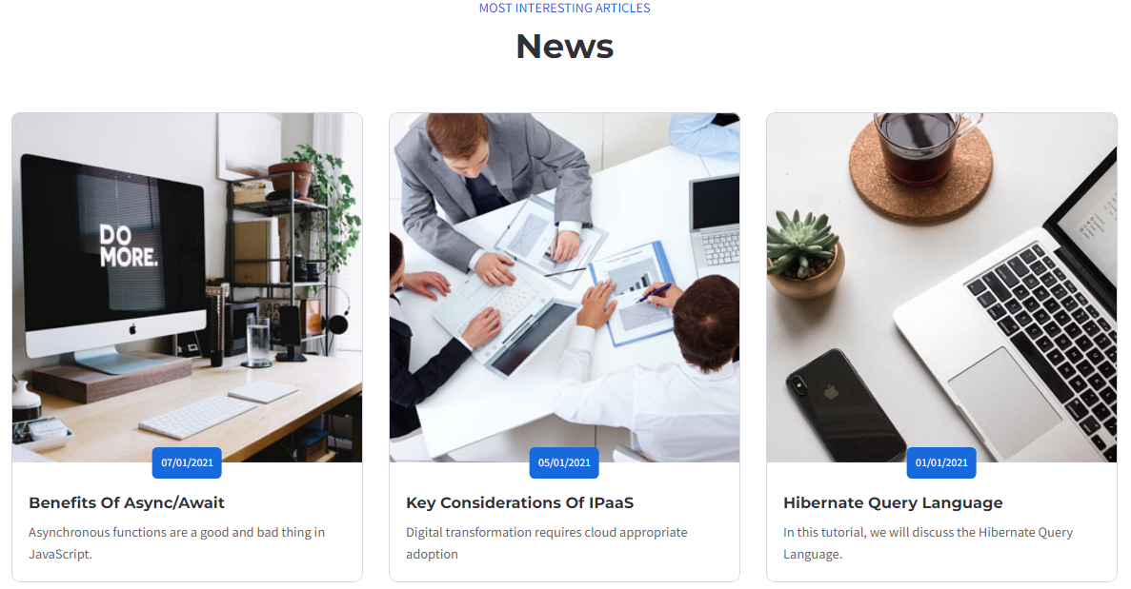

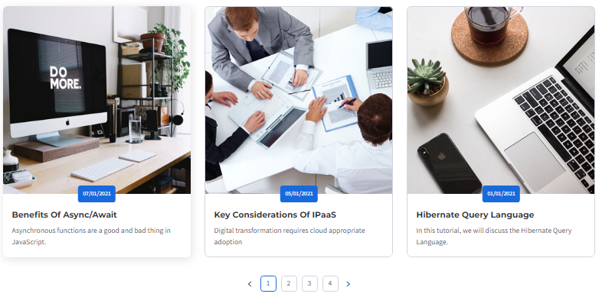

Send important news and notices.

## Association members

Introduction of members of the association (member profiles and pictures need to be provided by the association)



## Related Companies

It is mainly to simply display the information of the donor company. Business links. or a separate business card page.

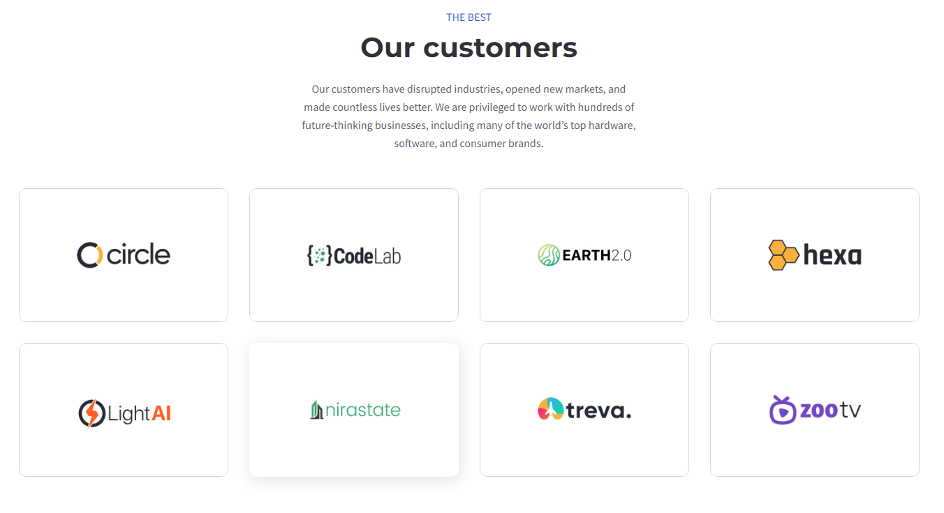

## Contact Us

Send information to the association mailbox.

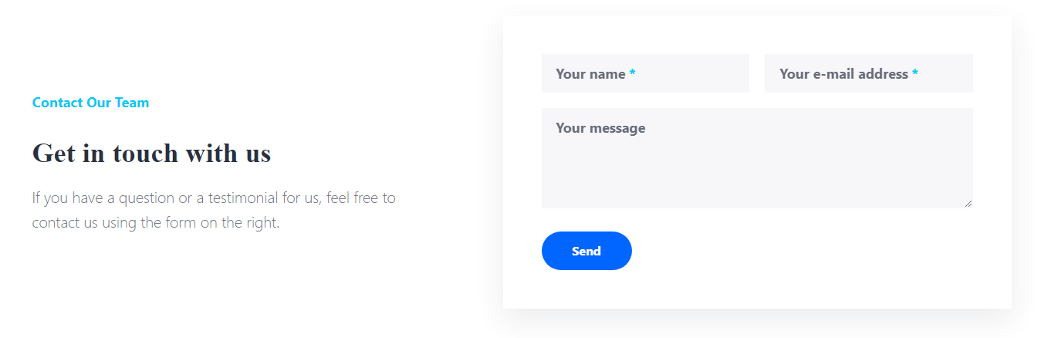

## Backstage Management

Association member registration and login interface, backstage management interface. News and notice release management, event display release management.

## Technology

[ASP.NET MVC Pattern](https://dotnet.microsoft.com/en-us/apps/aspnet/mvc)

Framework for Web UI - Blazor

Database - mysql.

## Next step plan

The first version of the project plan is a preliminary page design, involving primary functions, and a technical description of the selected development. After that, there will be detailed design documents concerning user stories, class diagrams, and database diagrams.